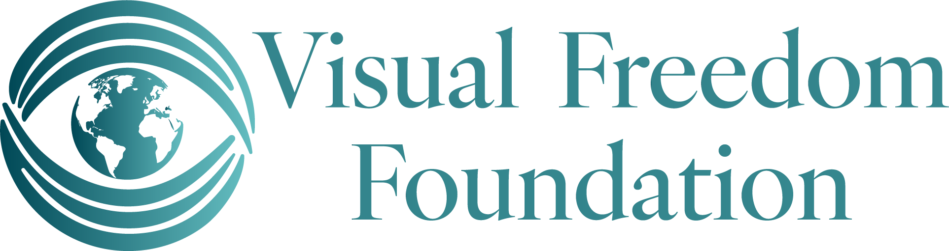

Visual Freedom Foundation – Frequently Asked Questions
1. What is the Visual Freedom Foundation?
The Visual Freedom Foundation (VFF) is a nonprofit organization committed to expanding access to free refractive surgery—including procedures like LASIK and PRK—for individuals who are uninsured, underinsured, or facing financial hardship. Through a nationwide network of volunteer surgeons, VFF restores sight and transforms lives by offering vision correction to those who would otherwise go without care.
VFF is especially dedicated to supporting amputees, paraplegics, and underserved communities around the world, where access to life-changing vision care is often limited or nonexistent. Our mission is to help people regain their sight, independence, and confidence, ensuring that everyone—regardless of their circumstances—can experience the freedom that comes with clear vision.

2. Who qualifies for complimentary vision correction surgery?
Eligible patients are those who:
- Are uninsured or underinsured
- Face significant financial hardship
- Have a refractive error treatable by surgery (e.g., nearsightedness, farsightedness, astigmatism)
- Are medically eligible for surgery based on a qualifying eye exam

3. Does Visual Freedom Foundation help with co-pays?
No. VFF only serves patients who are uninsured or lack the financial means to access surgery. It does not cover co-pays or costs associated with private insurance.

4. Do insured patients qualify for complimentary surgery?
In most cases, patients with insurance do not qualify, unless their plan does not cover refractive surgery and they meet VFF’s income and hardship criteria.

5. How does Visual Freedom Foundation financially qualify a patient?
Applicants are asked to submit documentation such as:
- Proof of income (e.g., tax return, pay stub)
- Proof of lack of insurance or underinsurance
- Any relevant information regarding financial hardship
Each application is reviewed on a case-by-case basis, with a focus on helping those in genuine need.

6. When and how are patients notified of their application status?
Applicants are typically notified of their status via email or phone within 2–4 weeks of submitting a complete application. Response times may vary based on regional surgeon availability and demand.

7. How long will it take for a patient to receive surgery after approval?
Wait times vary depending on location and surgeon availability. Most patients are scheduled for surgery within 1–3 months of approval.

8. What happens once the patient is matched with a volunteer surgeon?
The patient is contacted with details about the surgeon, location, and next steps. The volunteer surgeon or their team coordinates the initial evaluation and surgical scheduling directly with the patient.

9. What happens if the initial eye exam reveals another condition, such as glaucoma?
If a patient is found to have another eye condition that makes refractive surgery unsafe or inappropriate, they may be referred to another specialist for follow-up. VFF does not cover treatment for conditions like glaucoma or cataracts but can help guide patients to other resources when possible.

10. Does the patient supply their own transportation?
Yes. Patients are responsible for arranging their own transportation to and from exams and surgical appointments.

11. Who is responsible for post-op care?
The volunteer surgeon or their practice typically provides standard post-operative care, including follow-up visits related to the surgery. Any unrelated or long-term eye care needs fall outside the scope of VFF’s coverage.

12. What if the patient has additional questions?
Patients can contact the Visual Freedom Foundation directly by email at contact@visual-freedom.org.

